Okay, time for some fun. The following is a quiz game about Fred Beckey. The winner has a choice of either a pair of old socks chewed on by a snafflehound or a piece of horsec__k, I mean sausage.

**Question #1:** This is a four-part question:

Who is the person on the right side of the photograph?

What climbing achievement does Beckey share with this person?

What climb is this group going to attempt?

What year is this attempt?

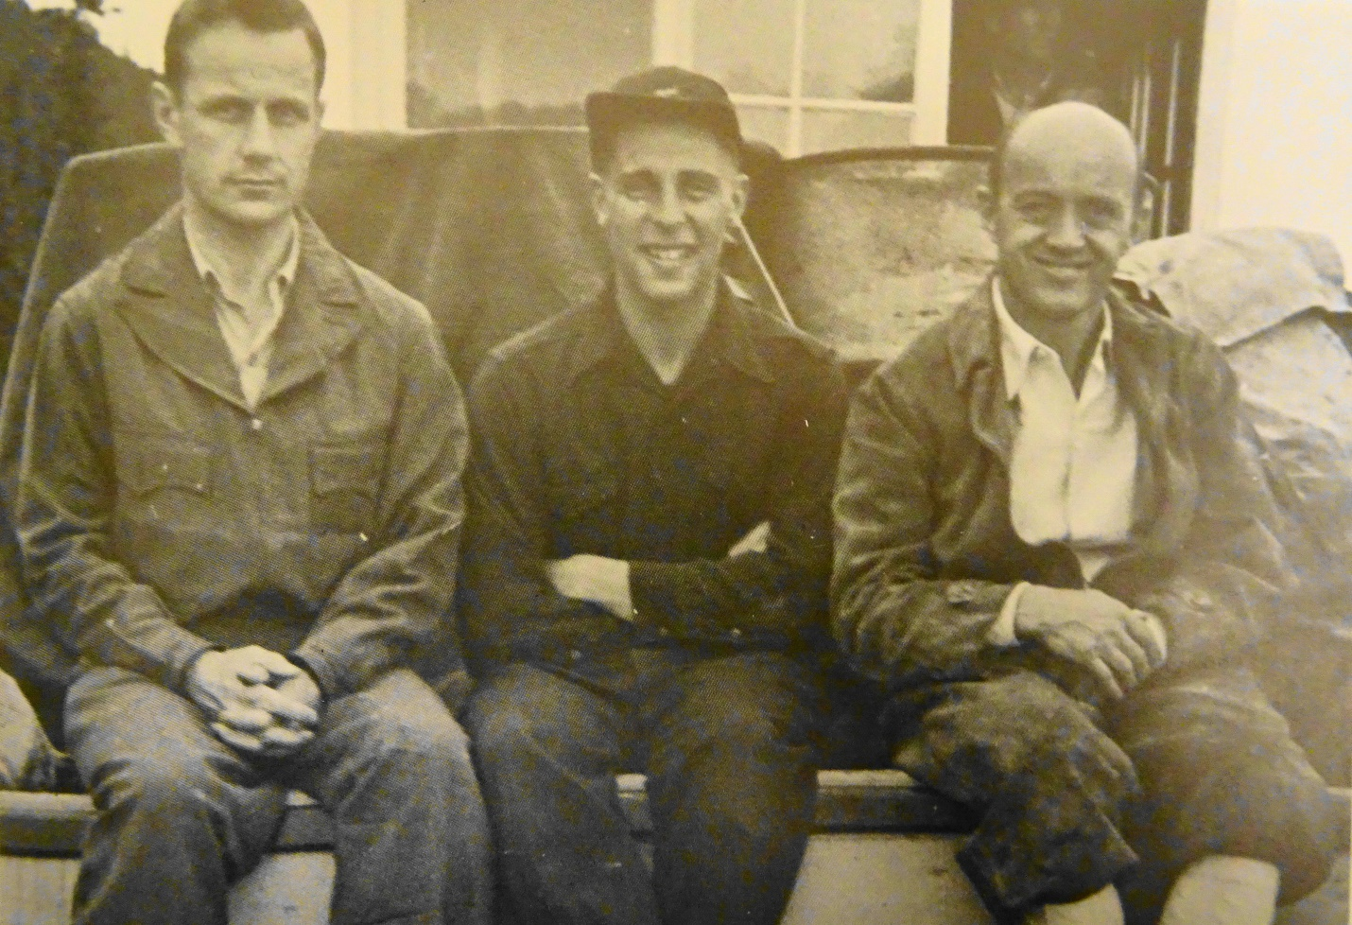

**Answers**

The person on the right-hand side of the photograph is Fritz Wiessner.

Fritz Wiessner and Bill House made the first ascent of Mt Waddington in July 21, 1936, while Fred and Helmy Beckey made the second ascent on August 6, 1942.

The person on the left-hand side of the photo is Don Brown. The three climbers are hitching a ride 70 miles up the Stikine River on Al Richie’s river boat on July 10, 1946, to make an attempt on Devils Thumb on the Alaska, British Columbia border from the Canadian side.

Don Brown and Fritz Wiessner had previously been on an expedition in the Stikine Icecap in 1937. Fritz Wiessner would sprain his knee on this approach. The group would turn back on July 17, 1946 because of Wiessner’s injury.

Photo by: unknown. Summit Magazine, March 1973, page 5. *Stikine Wilderness*, by Fred Beckey.

**Question #2:** Which of the following peaks did Fred Beckey climb to the summit?

1. Denali, aka Mt McKinley, Alaska
2. Mt Terror, Washington
3. Mt Assiniboine, Alberta
4. Bonanza Peak, Washington
5. Pernod Spire, Washington
6. DAFF Dome, California
7. Longs Peak, Colorado

**Answer:** none of the above.

**Question #3:** Which of the following routes were named after Fred Beckey, even though he did not make the first ascent or new route on it, but eventually he would climb it?

1. Elephant Perch, Beckey Direct, Idaho
2. Lone Pine Peak, Bastille Buttress-Beckey Route, California
3. Grand Teton, Route #11-Beckey Couloir, Wyoming
4. Gate Buttress, Beckey’s Wall, Utah
5. Spring Lake Wall, Beckey Route, California

**Answer:** a) and c).

**Question #4**: Four-part question.

Identify which person in the following photograph is Fred Beckey?

Identify another prominent Northwest climber is in the following photograph?

Identify where they are climbing?

What year is it?

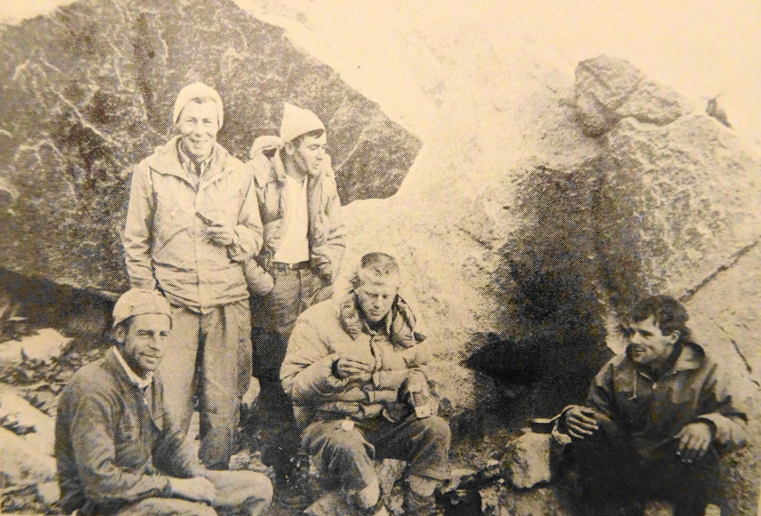

**Answers:**

Fred Beckey is at the far left, sitting down.

The prominent Northwest climber is Dan Davis is at the far right, sitting down.

Location is Lone Peak Cirque, Wasatch Mountains, Utah.

Date was September 1962.

FYI: The other three climbers in the middle are (Left to right): Rich Ream, Teddy Wilson and Court Richards.

Photo by: Rich Ream. Summit Magazine, December 1962. *Question Mark Wall,* page 14.

**Question #5:** Who is person that made the most consecutive successful climbs with Fred Beckey?

1. Pete Schoening
2. Dan Davis
3. Eric Bjornstad
4. Don Gordon
5. Helmy Beckey

**Answer:** Dan Davis. He was successful on 28 consecutive climbs with Fred Beckey, which was all the climbs that Davis and Beckey did together.

**Question #6:** Two-part question.

What peak is Fred Beckey on top of?

What year is it?

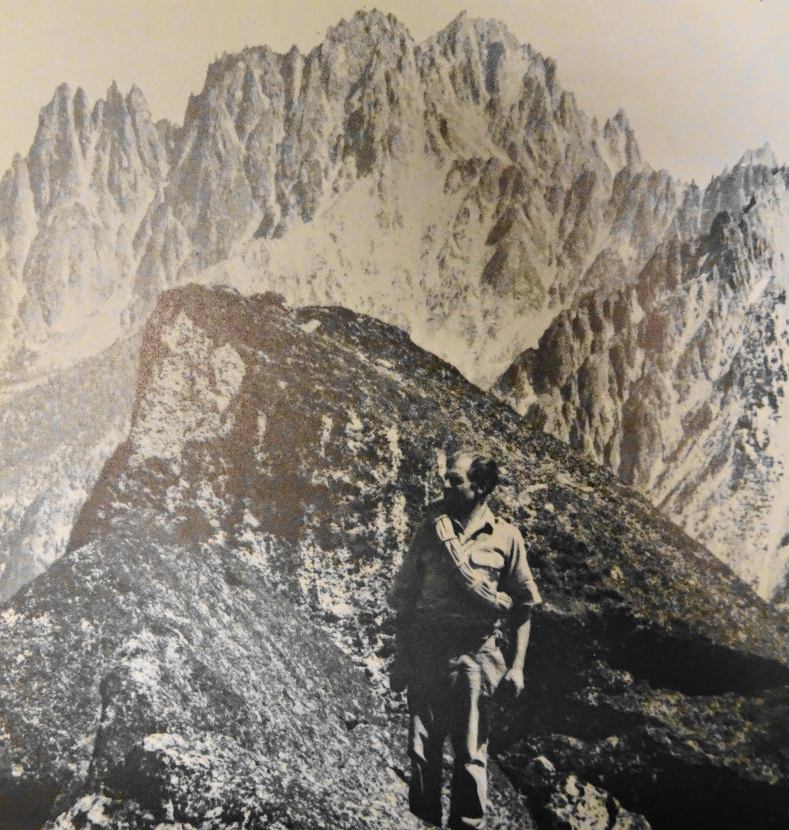

**Answer:** South Early Winter Spire, on September 29, 1968.

FYI: Doug Leen and Fred Beckey established a new route, via the East Buttress Direct. In the background, left to right are: Burgundy Spire, Chianti Spire, Pernod Spire, Chablis Spire, Silver Star Mountain-West Peak and Silver Star Mountain-East Peak.

Photo by: Doug Leen. Summit Magazine, December 1969. *South Early Winter Spire,* pages 16-21, by Fred Beckey.

**Question #7:** Four-part question.

See if you have hawkeyes and can identify which person is Fred Beckey in this photograph.

What mountain is this group of climbers on the summit of?

What club of climbers is Fred Beckey with?

What year is it?

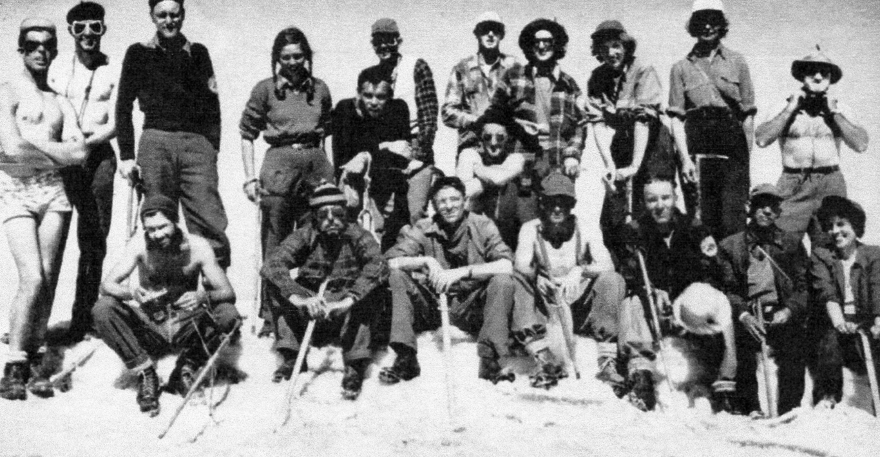

**Answers:**

Fred Beckey is standing at the far left.

The group is on the summit of Mt Baker.

The club of climbers are the Iowa Mountaineers, which was affiliated with the University of Iowa at that time.

The date was August 27, 1949.

Here is what Beckey stated in his book *Challenge of the North Cascades*, in the Appendix: Chronology of Climbs for 1949 on page 265: Baker via Coleman Glacier. Climbed in swim suit.

Photo by: Edith Stettner. The Iowa Climber Volume III, No. 3, 1950. *Washington Climbing Holiday*, page 64. By Joan Cox.

**Question: #8:** Who is the person who made the most consecutive climbs which were either a first ascent or new route with Fred Beckey?

1. Steve Marts
2. Eric Bjornstad
3. Pete Schoening
4. Dan Davis
5. Don Gordon

**Answer:** Dan Davis. He and Fred Beckey climbed together on 14 consecutive climbs which were either a first ascent or new route during 1962-1963.

**Question #9:** True or false. Did Fred Beckey and his climbing partner(s) make the first winter ascent of Mt Robson?

**Answer:** Close, but not quite.

Beckey was in Colorado when he received a phone call from Alex Bertulis that the conditions and weather were right for an attempt on Mt. Robson. Bertulis soon left Seattle with Leif-Norman Patterson for British Columbia. Meanwhile Beckey left Colorado and arrived in Seattle but needed to find an available climbing partner. Finally, he recruited Tom Stewart and they soon left for Mt. Robson.

Meanwhile Bertulis and Patterson arrived at Mt. Robson and began their ascent of mountain via the Tumbling Glacier & Helmet Col Route. Beckey and Stewart arrived one day after Bertulis and Patterson arrival and began their climb of Mt Robson via the Robson Glacier, Kain East Face Route.

Bertulis and Patterson arrived at the summit of Mt. Robson two hours before Beckey and Stewart. They met Beckey and Stewart for the first time during their descent, several feet beneath the summit.

Below is a front-page article and photograph from the *The Province* newspaper in Vancouver, about the climb.

Patterson proudly holding up his ice axe with the Norwegian flag attached to the shaft.

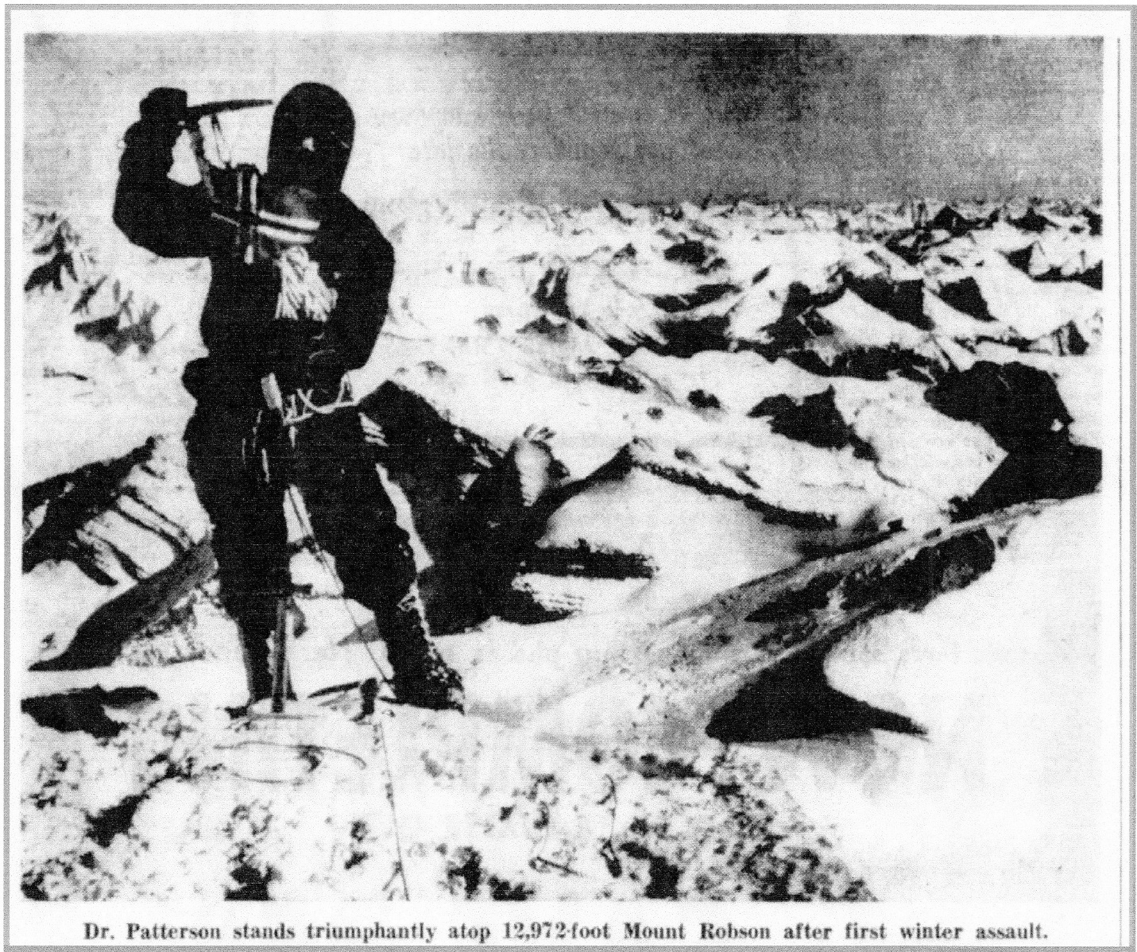

*The Province*, March 15, 1965, 1. Photo by Alex Bertulis.

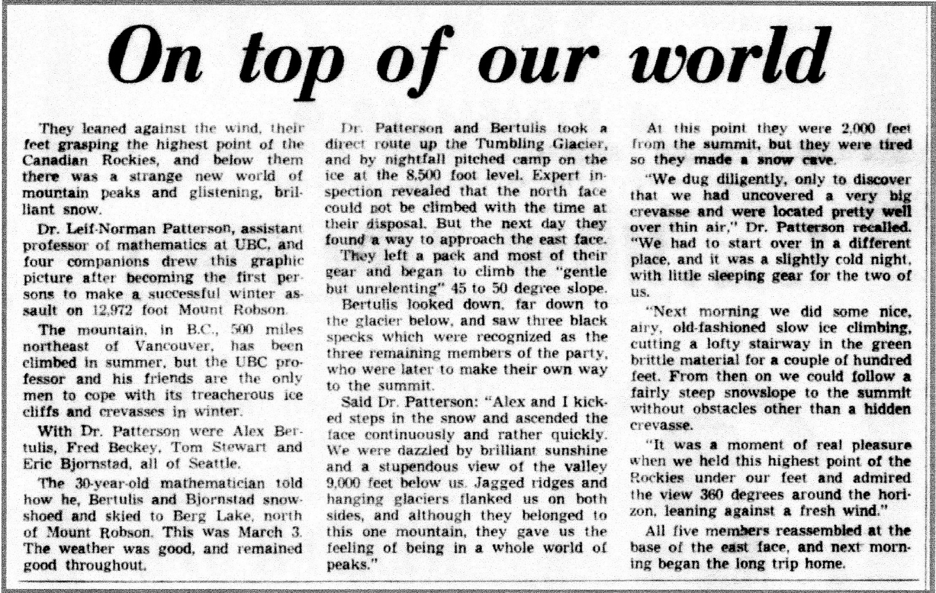

*The Province*, March 15, 1965, p 1.

**Question #10:** Answer the following questions about this photograph.

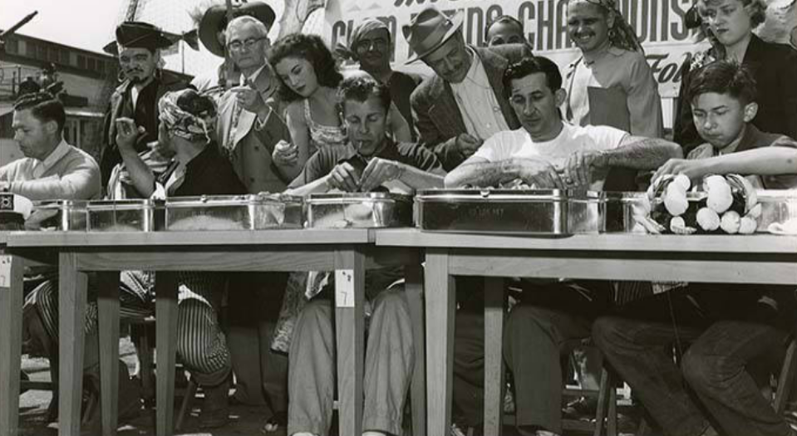

Identify which person is Fred Beckey.

What are these people doing?

Where was the photograph taken?

When was the photograph taken?

**Answers**

Fred Beckey is seated in the middle of the photograph. The people are participating the International Pacific Free Style Amateur Clam Eating Contest, in Seattle at Pier 54, on May 23, 1953.

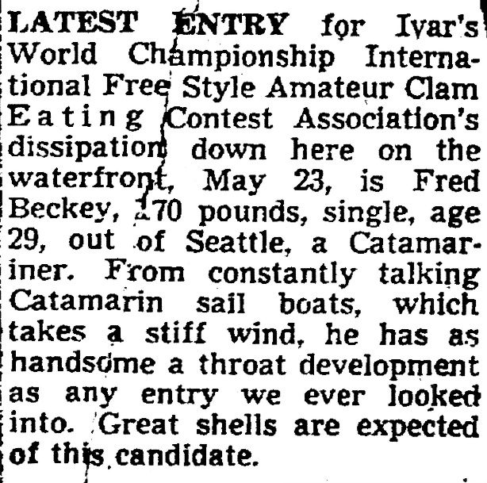

*Seattle Times.* May 1, 1953, 2.

In this corner, born in Zuelpich, Germany, now living in Seattle, Washington, Kya (Fred) Wolfgang Beckey! The 29-year old contestant, stand 6 feet tall and tips the scales at 170 pounds

However, the man seated to Fred’s left, Joe Gagnon, won the contest.

He coulda had class. He coulda been a contender! He coulda been somebody instead of a climbing bum.

Below is the full photograph, along with an article. The reigning Seafair Queen Iris Adams leans over Beckey’s right shoulder to keep track of how many clams he has eaten with a tally counter. Beckey came in second, by eating 342 clams in 10 minutes. Davey Jones’ pirates look on, to make sure Beckey behaves himself. Arrr!

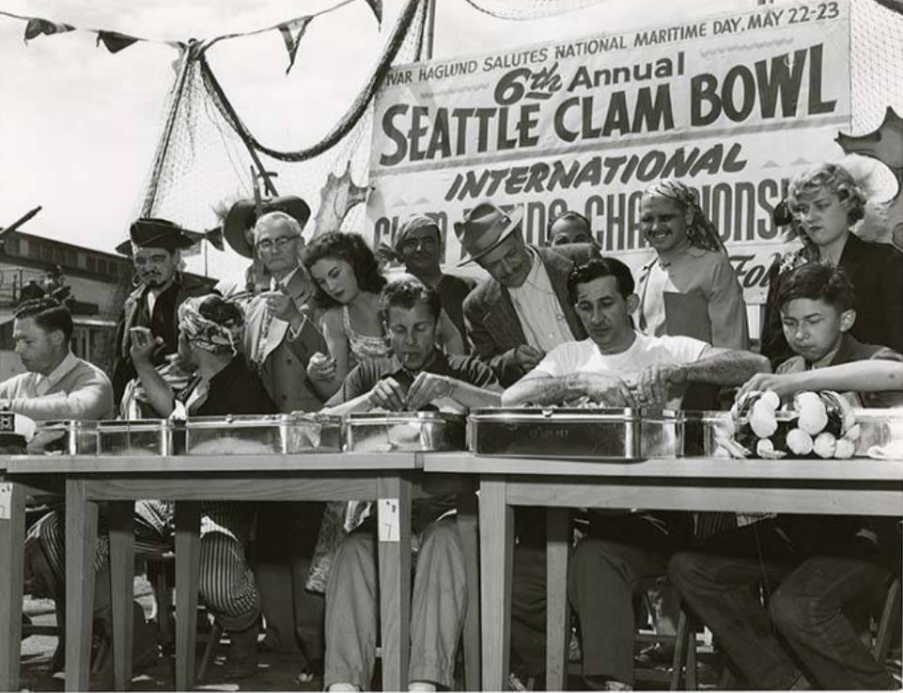

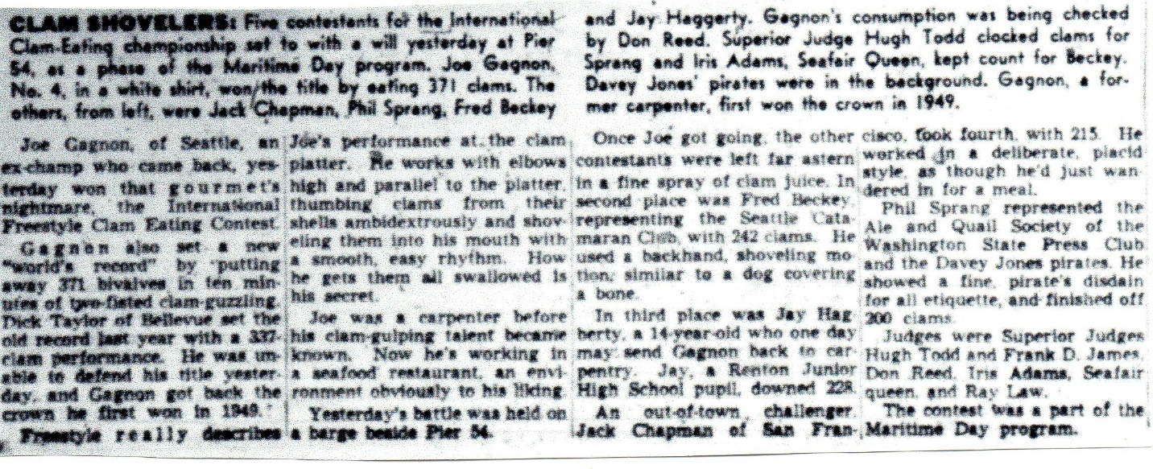

*Seattle Times*, May 24, 1953, 10.

**Question #11:** Answer the following questions.

Where is Fred Beckey?

What is he about to do?

What year is it?

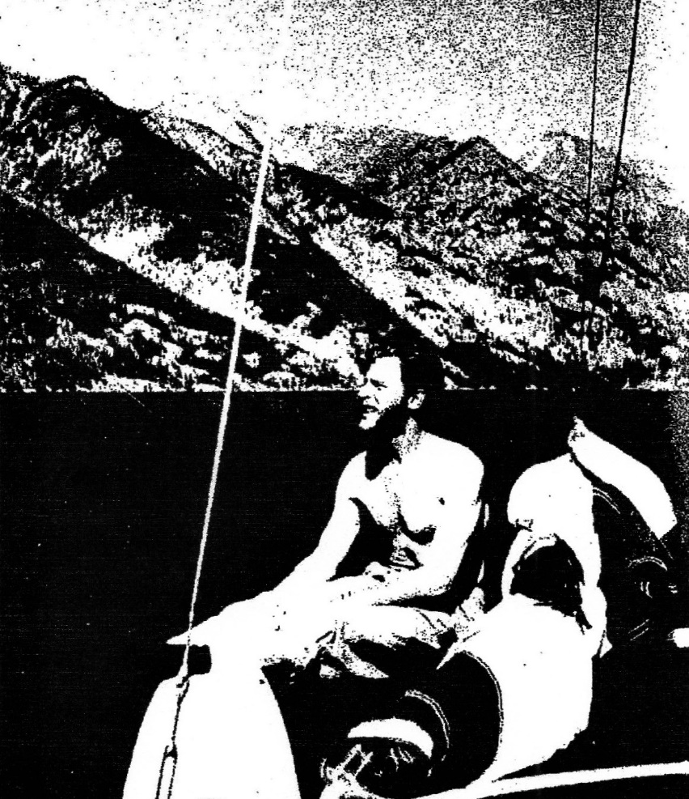

**Answers**: Beckey is at Lake Chelan State Park. He is on the red and white colored “Gay Cat” Catamaran, which he sailed north on Lake Chelan with John Parrott to the small town of Stehekin. Then they hiked into position for a climb the Northeast Face of Mt Goode, a new route, on July 19, 1954.

See below for a two-page article in the Seattle Times.

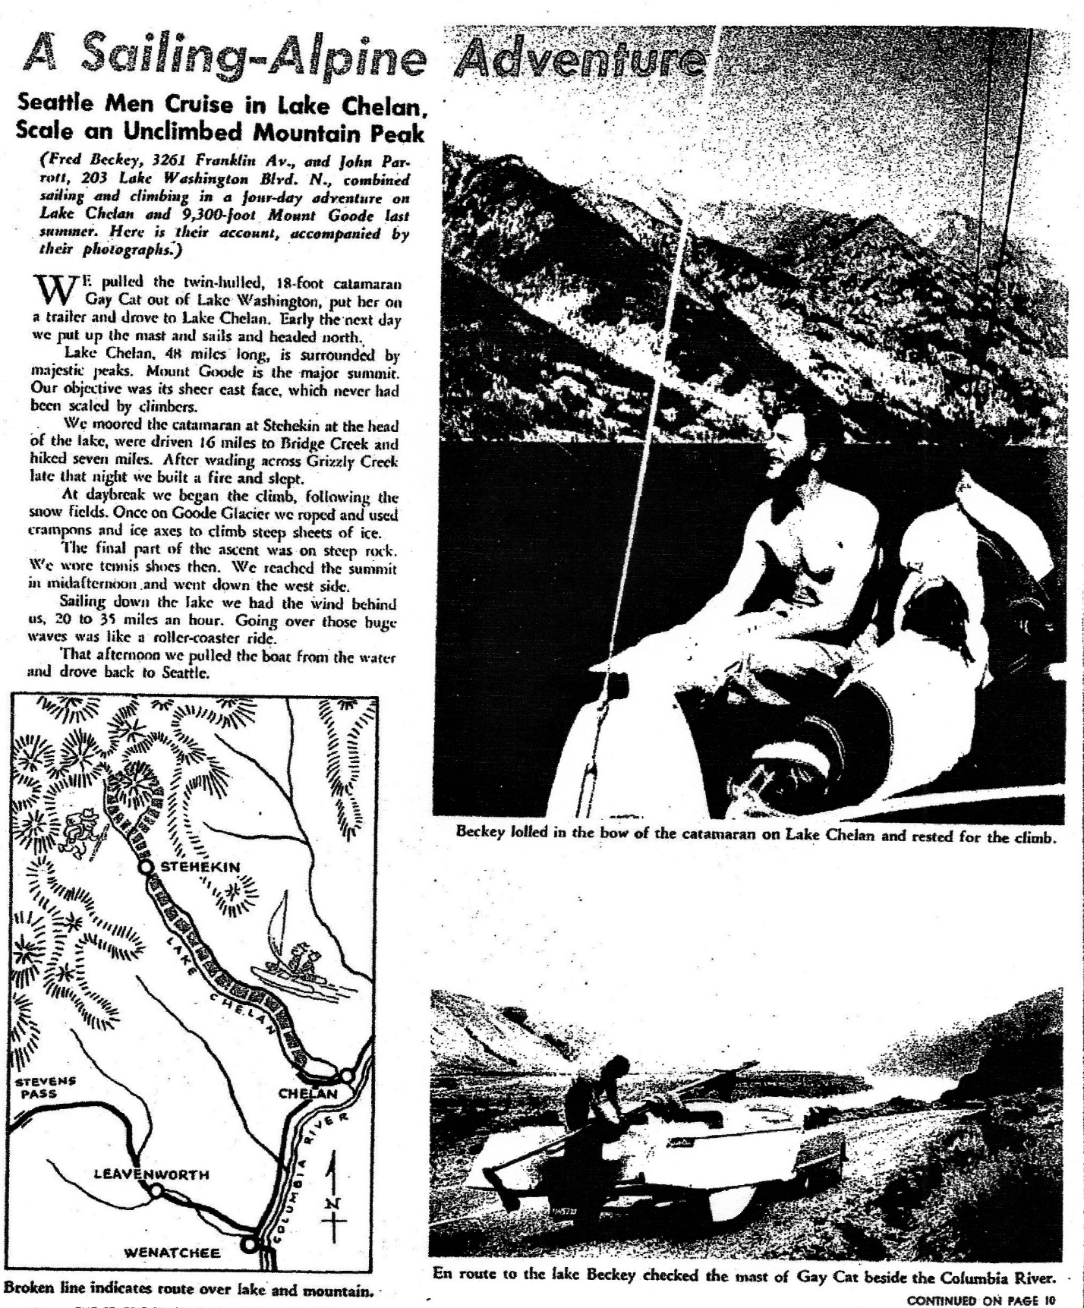

*Seattle Times*. February 6, 1955, 9

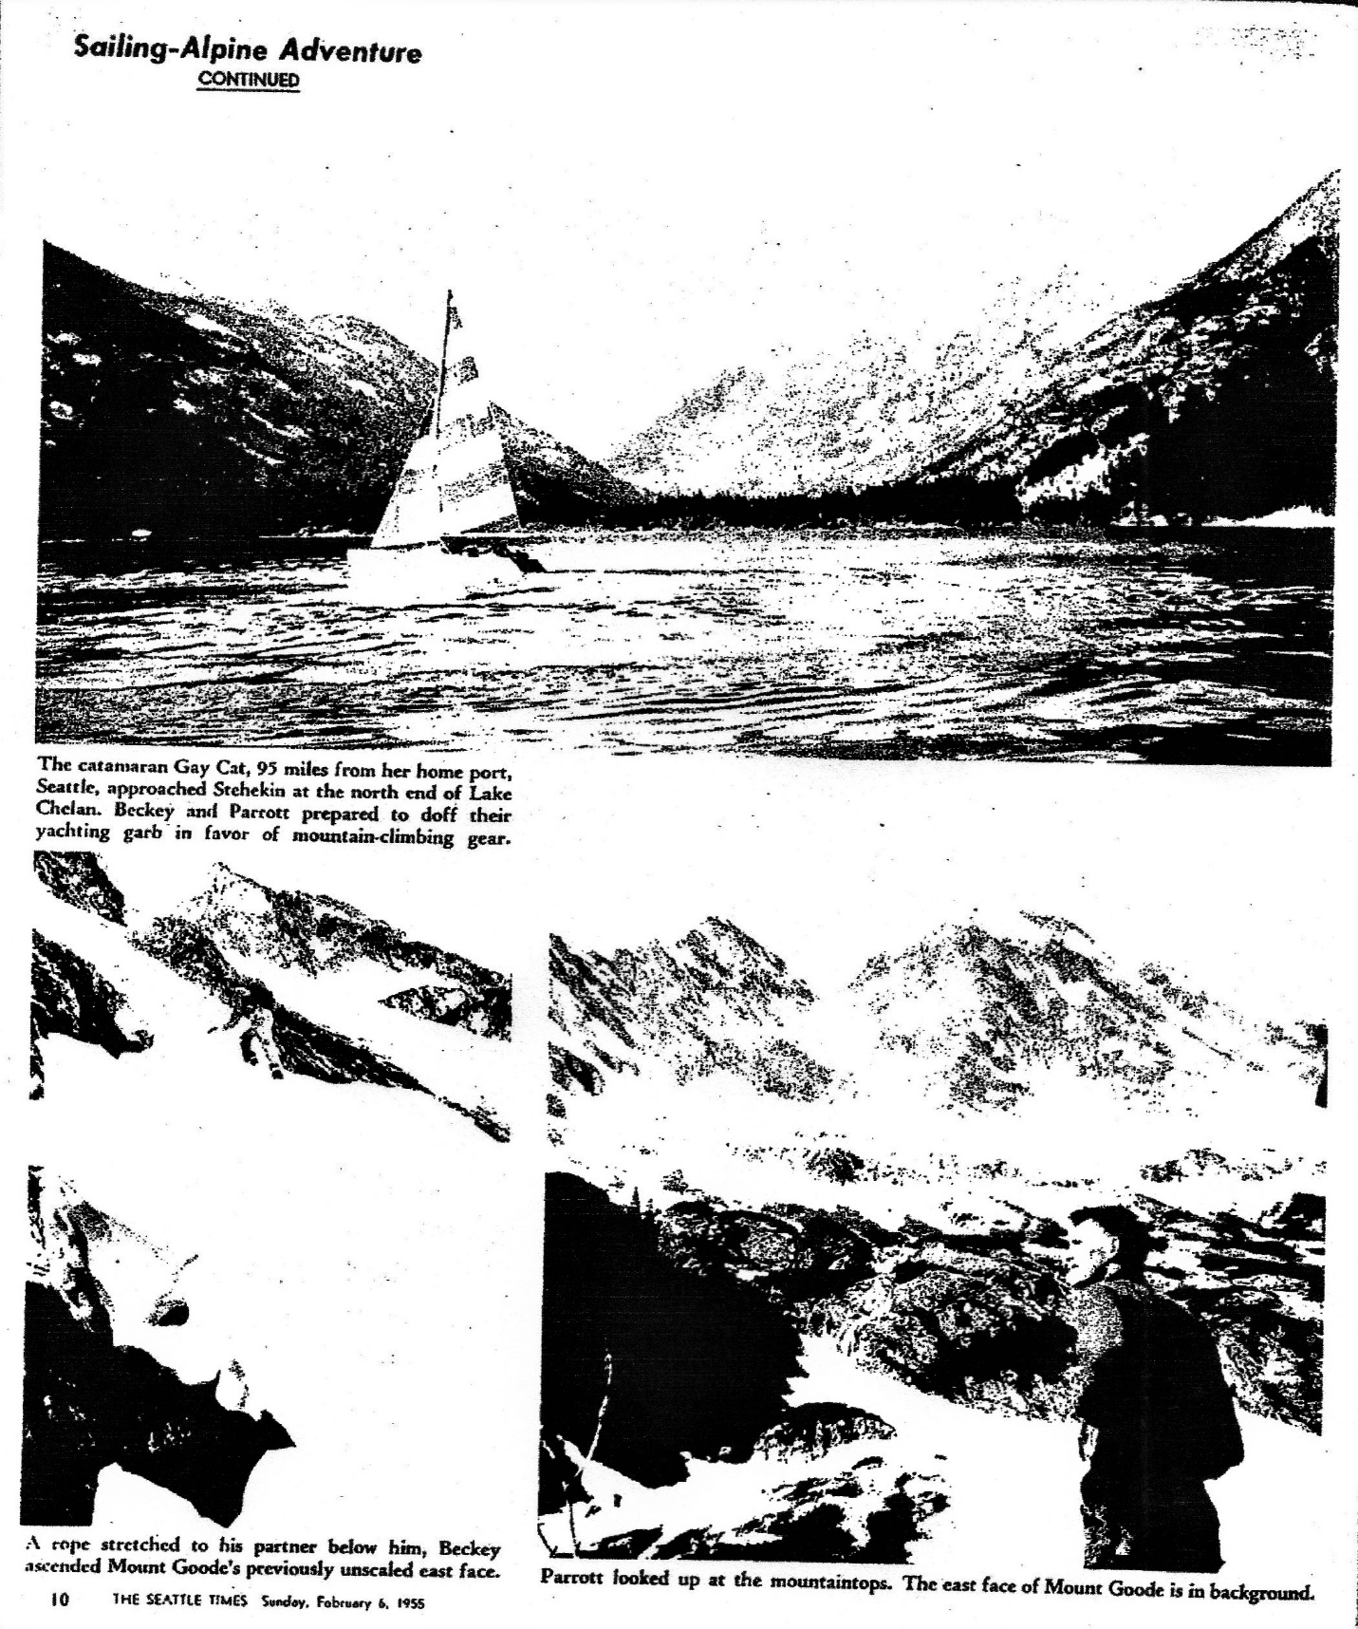

*Seattle Times*. February 6, 1955, 10

Author: Dave Creeden.